EXPERIMENT-1

1]FIND MOVIES MADE AFTER 1997.

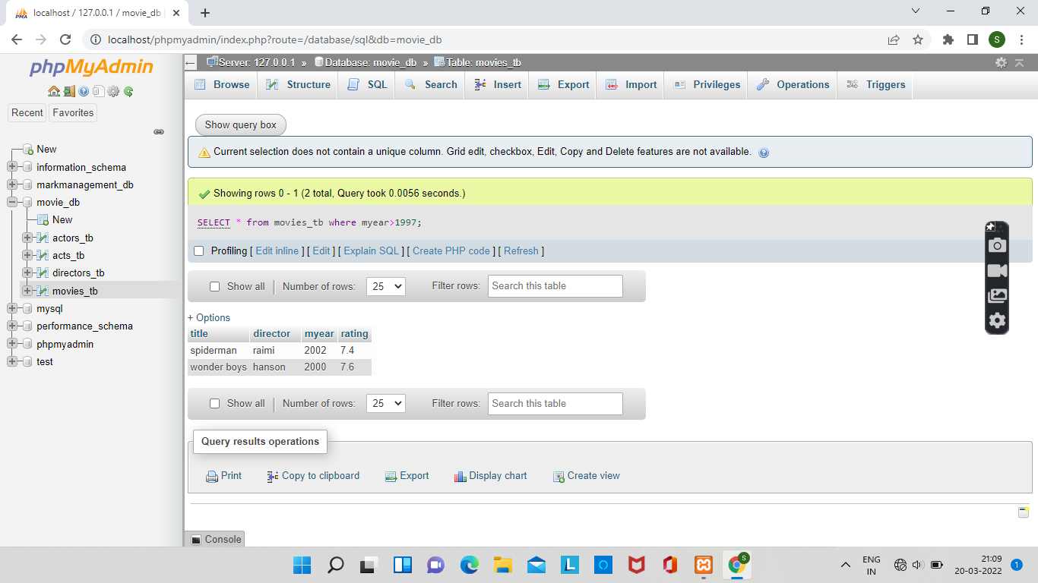

2]FIND MOVIES MADE BY HANSON AFTER 1997.

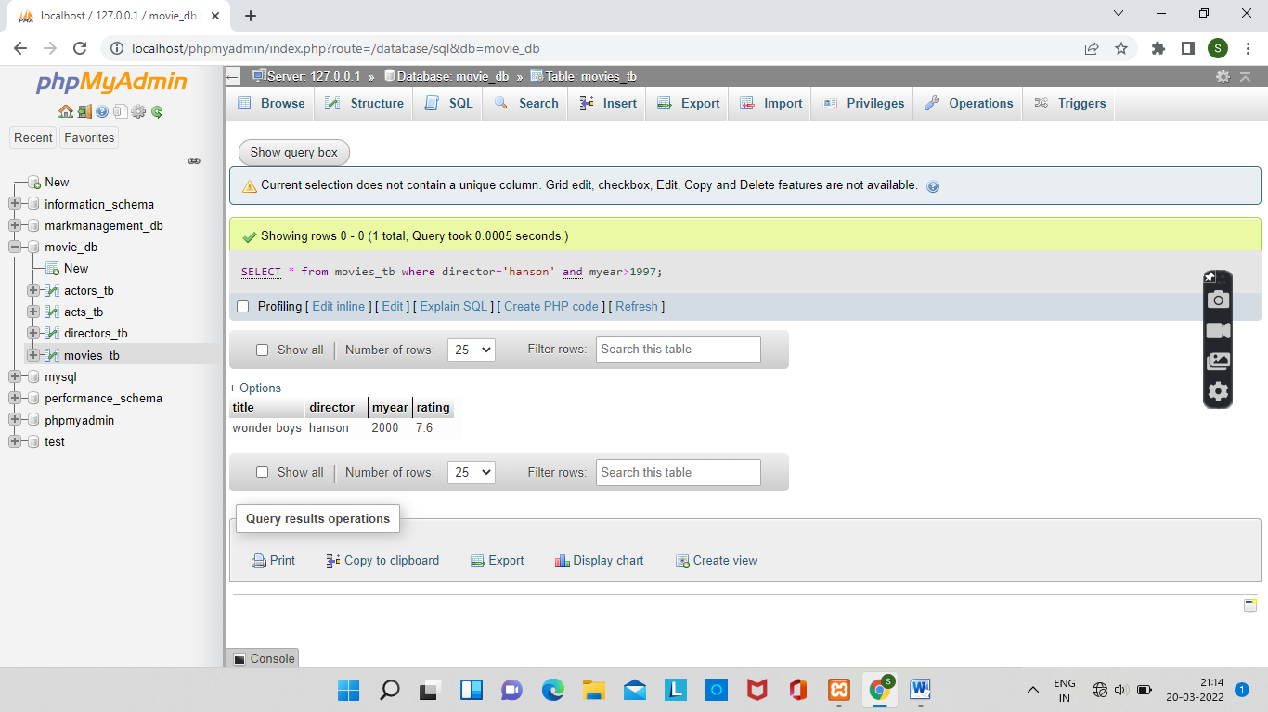

3]FIND ALL MOVIES AND THEIR RATINGS.

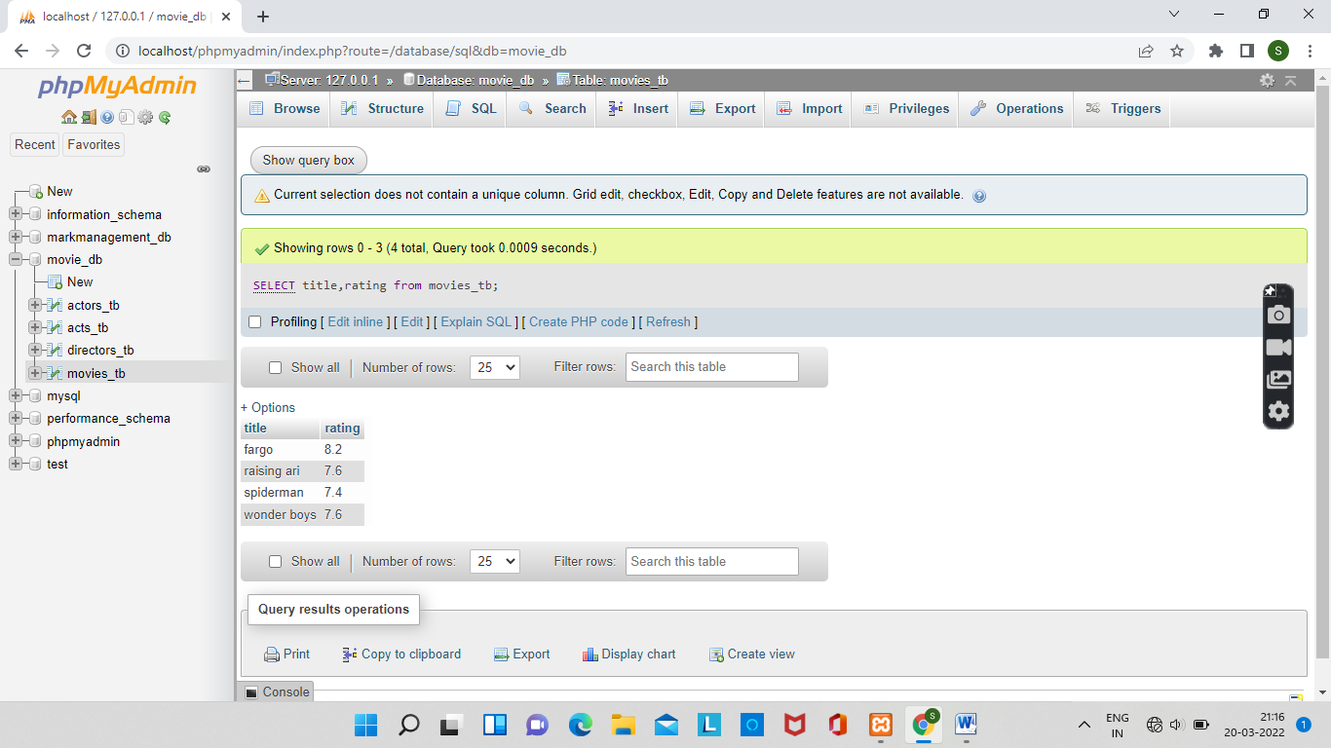

4] FIND ALL ACTORS AND DIRECTORS.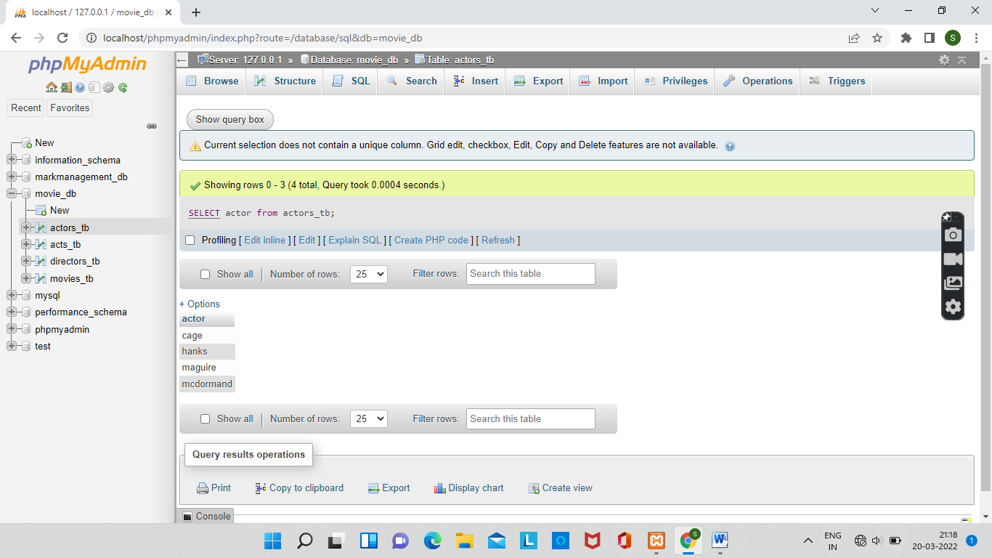

5]FIND COEN’S MOVIES WITH MCDORMAND.

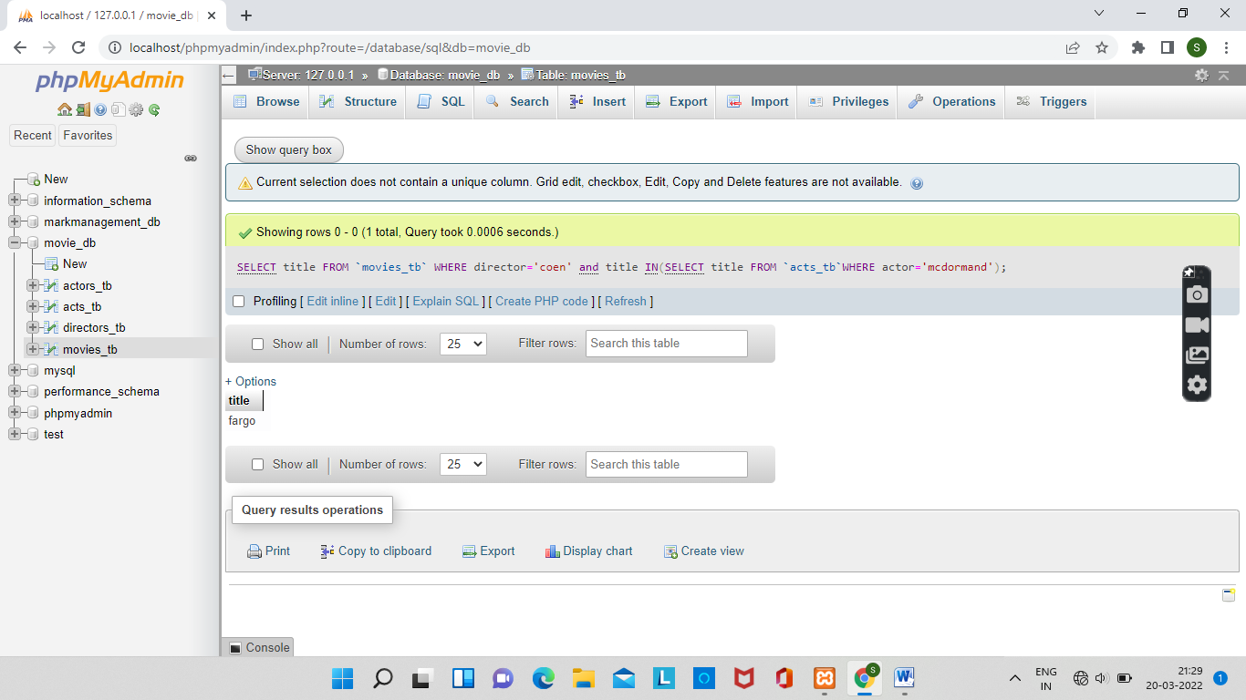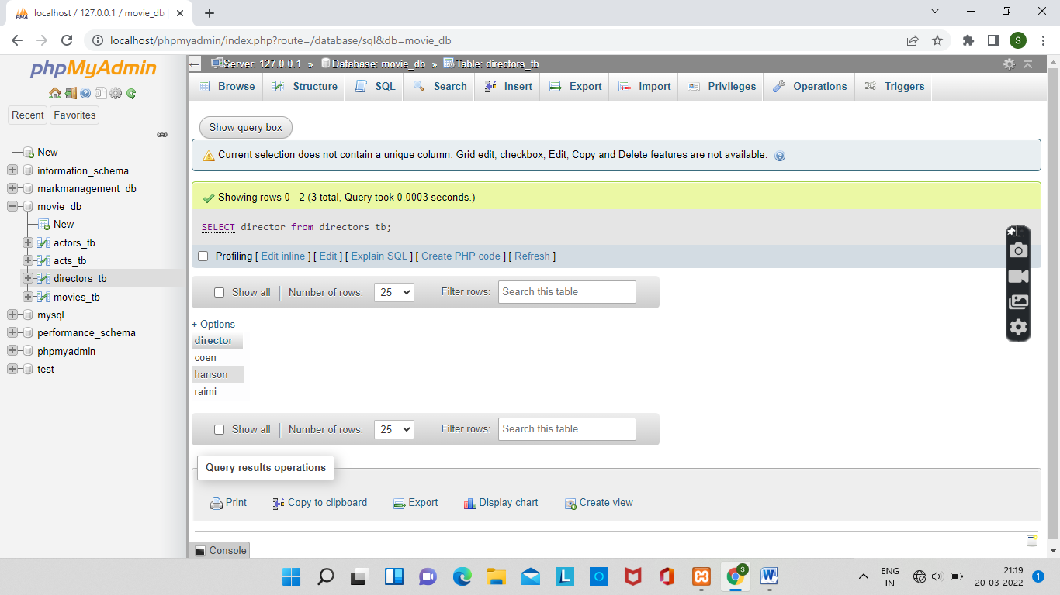  
Experiment-4

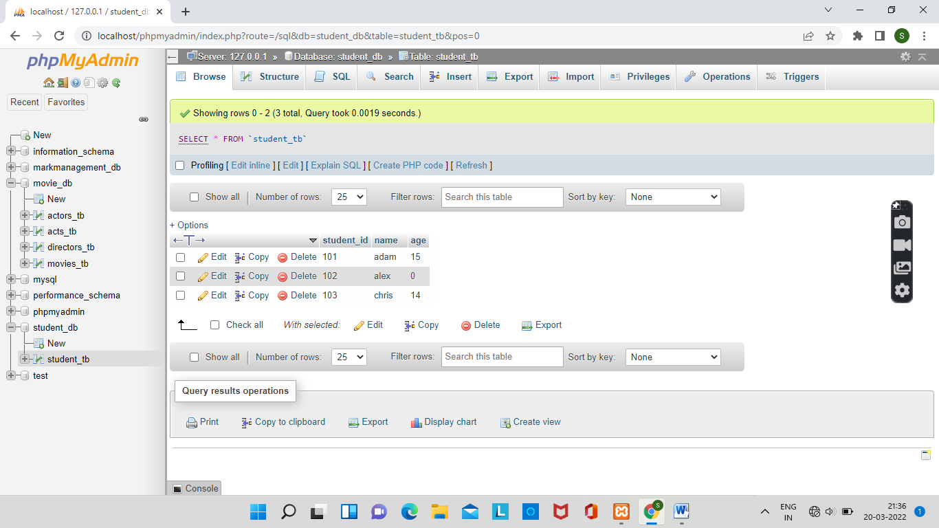

1] UPDATE COLUMN ‘AGE’ OF THE RECORD WHICH HAS S_ID 102.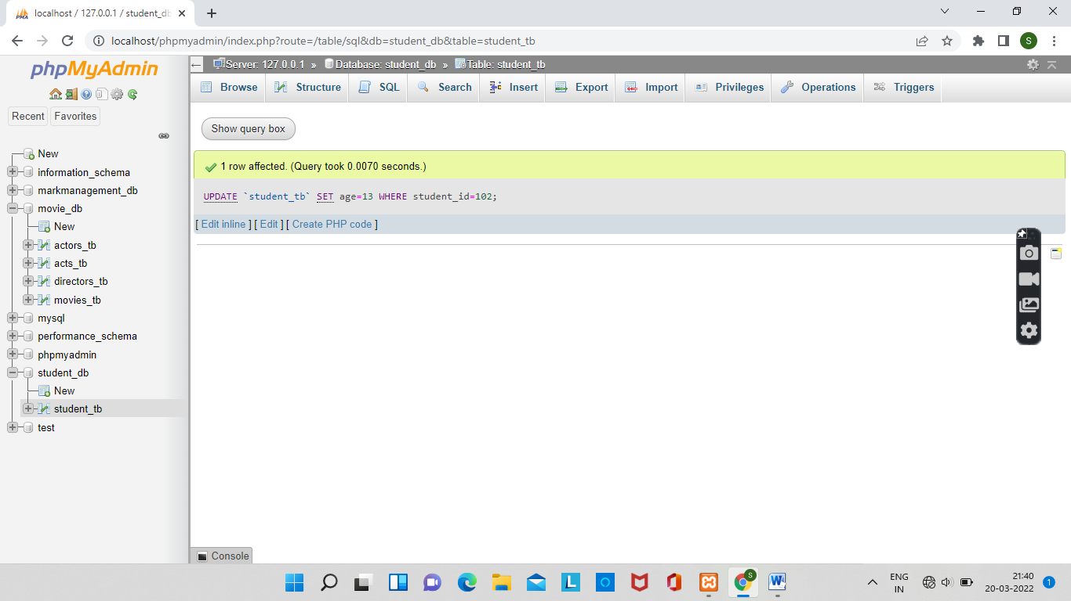

2]UPADTE TWO COLUMNS OF THE RECORD WHICH HAS S_ID 103.

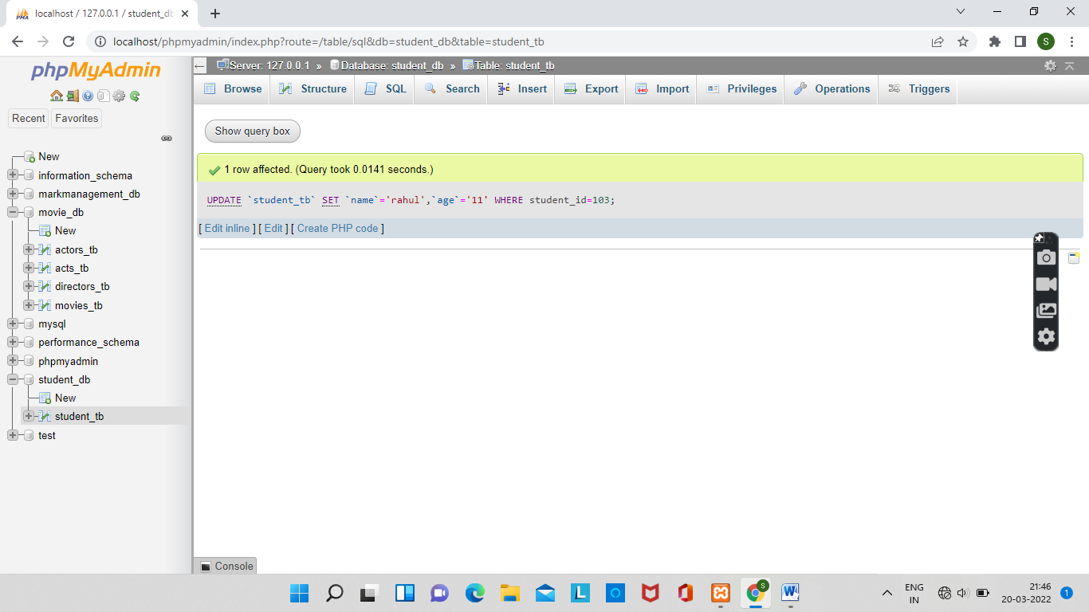

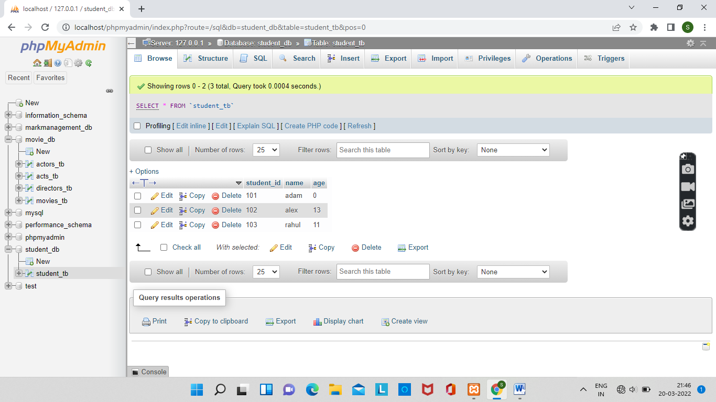

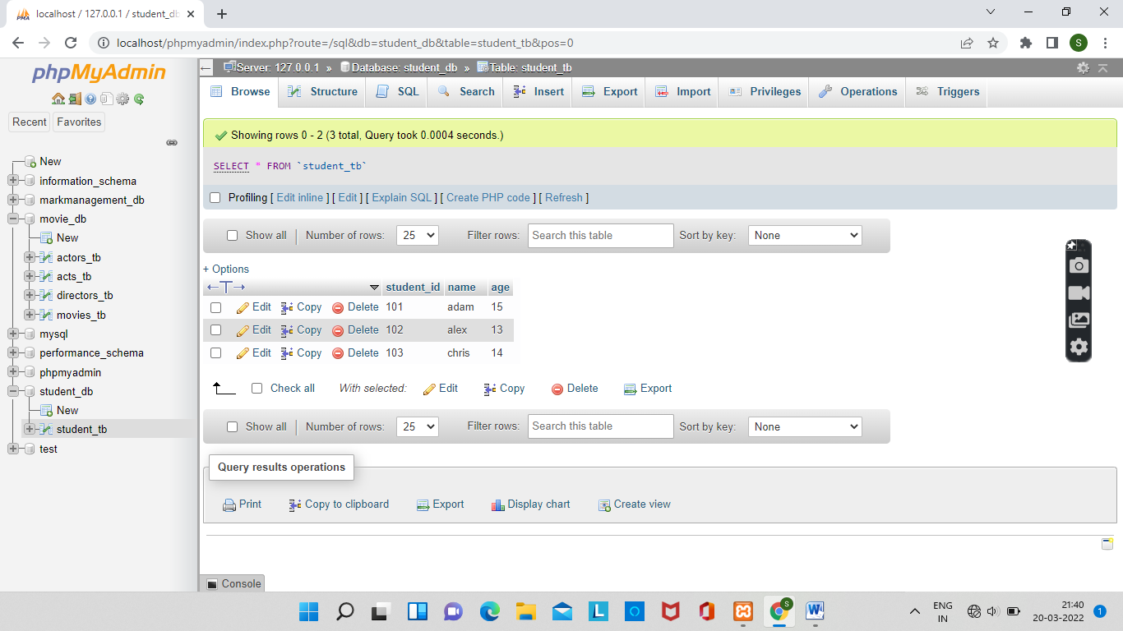

Experiment -5

1] BASED ON THE EMPLOYEE TABLE,DELETE ALL EMPLOYEE RECORDS WHOSE SALARY IS GREATER THAN60,000.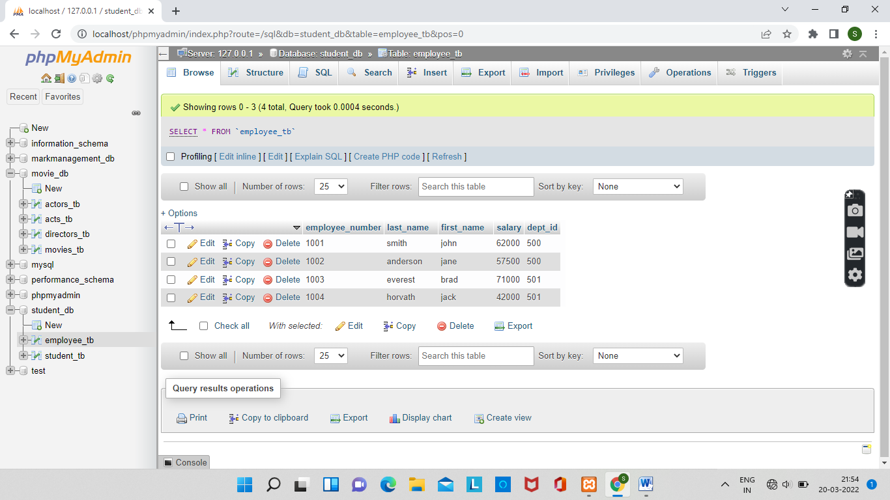

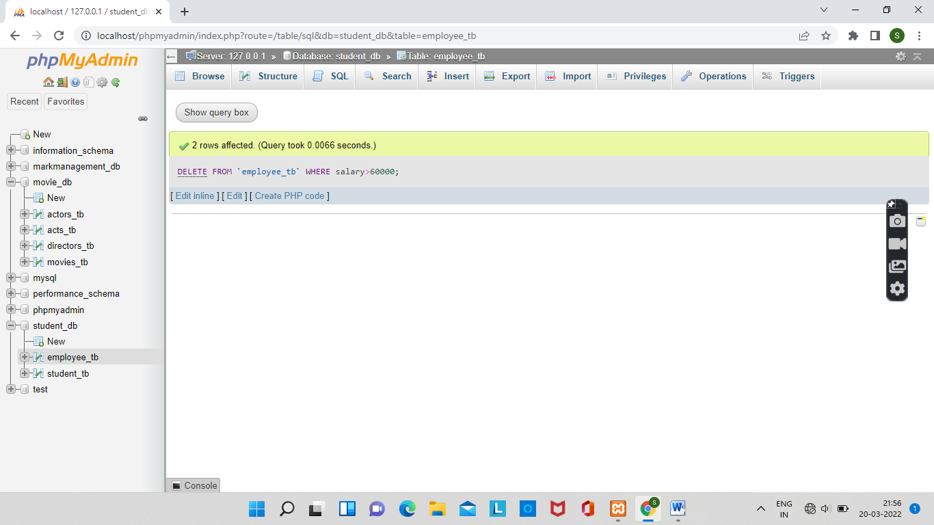

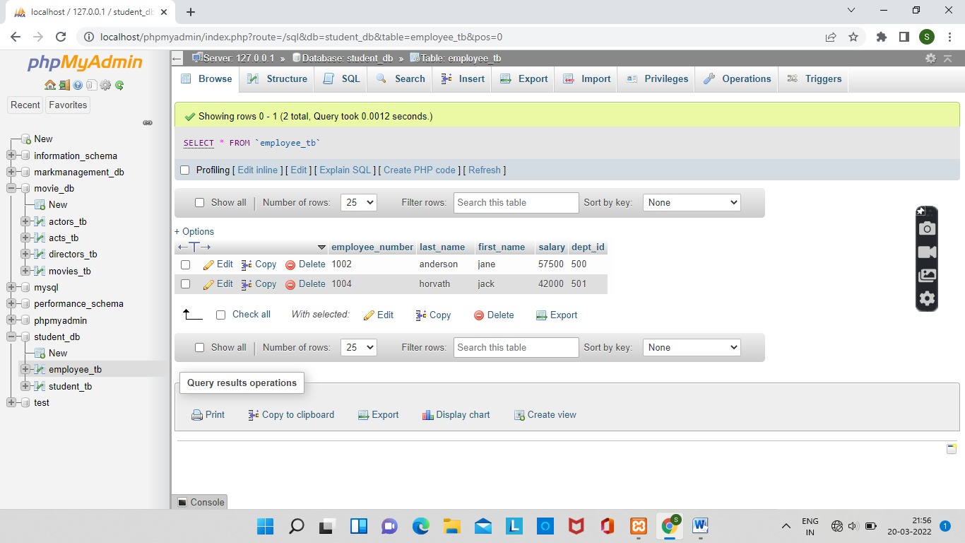

Experiment-2

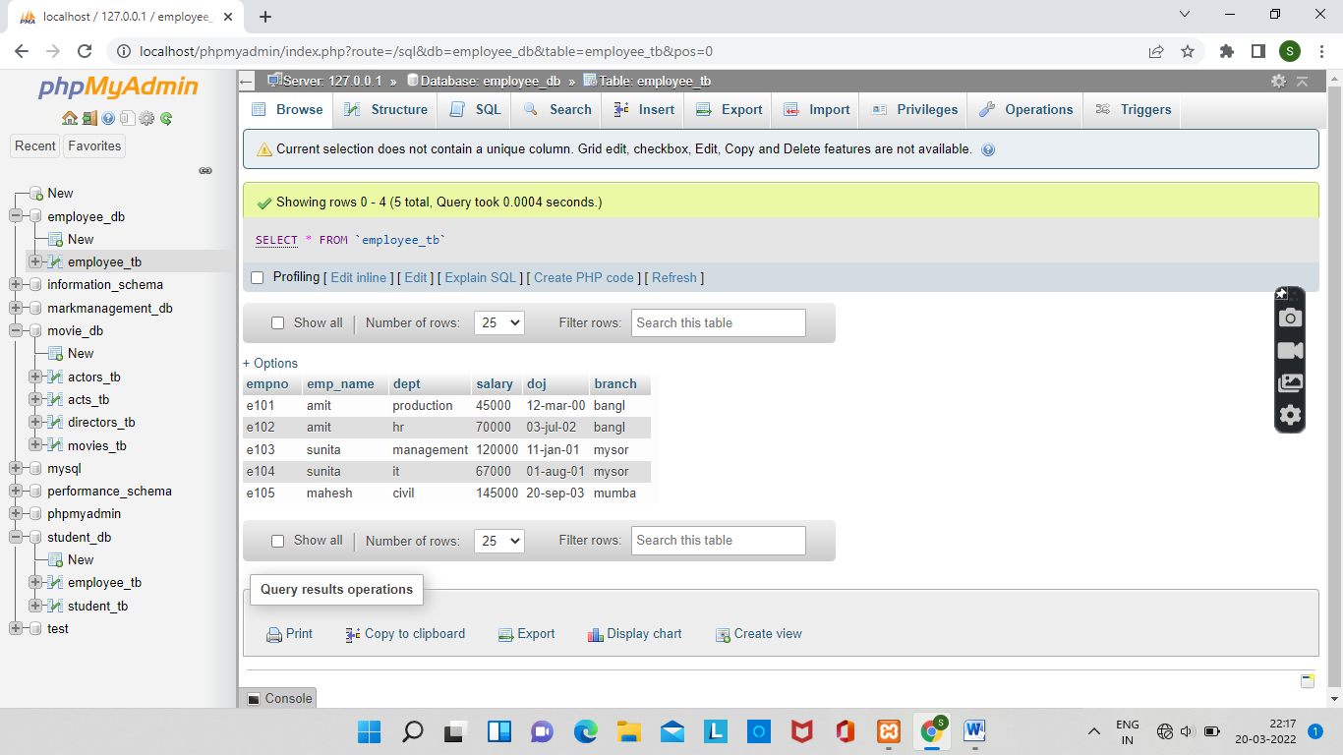

1] DISPLAY ALL THE FIELD OF EMPLOYEE TABLE.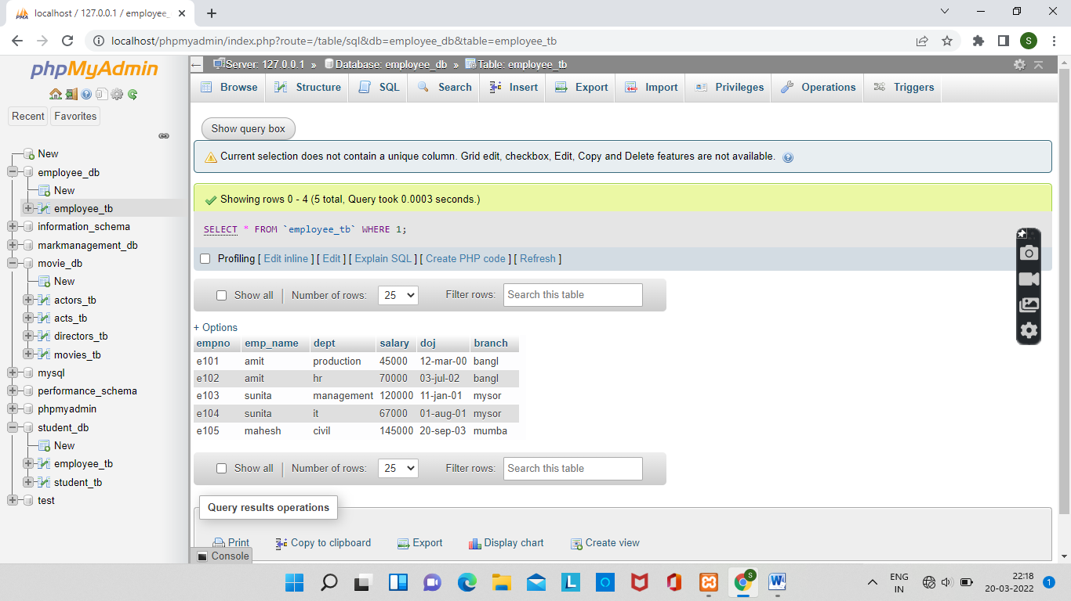

2]RETRIEVE EMPLOYEE NUMBER AND THEIR SALARY.

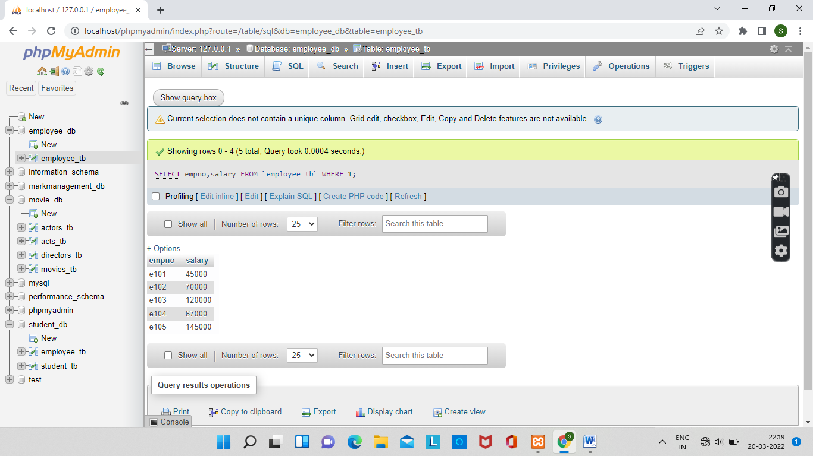

3]RETRIVE AVERAGE SALARY OF ALL EMPLOYEE.

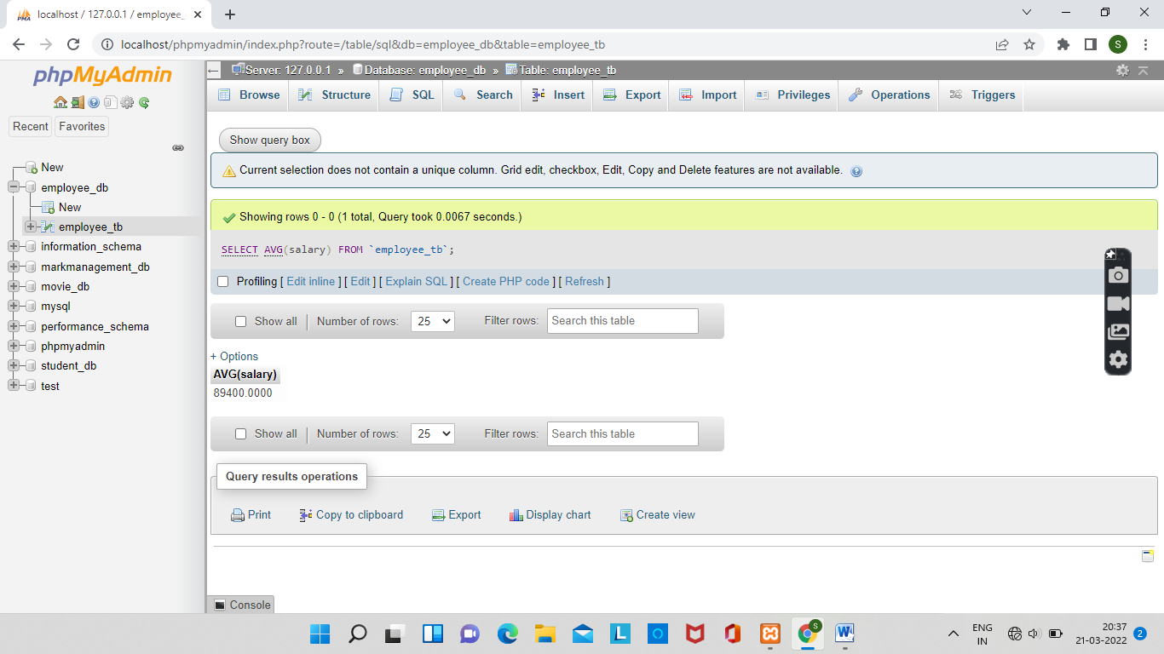

4]

RETRIEVE NUMBER OF EMPLOYEE.

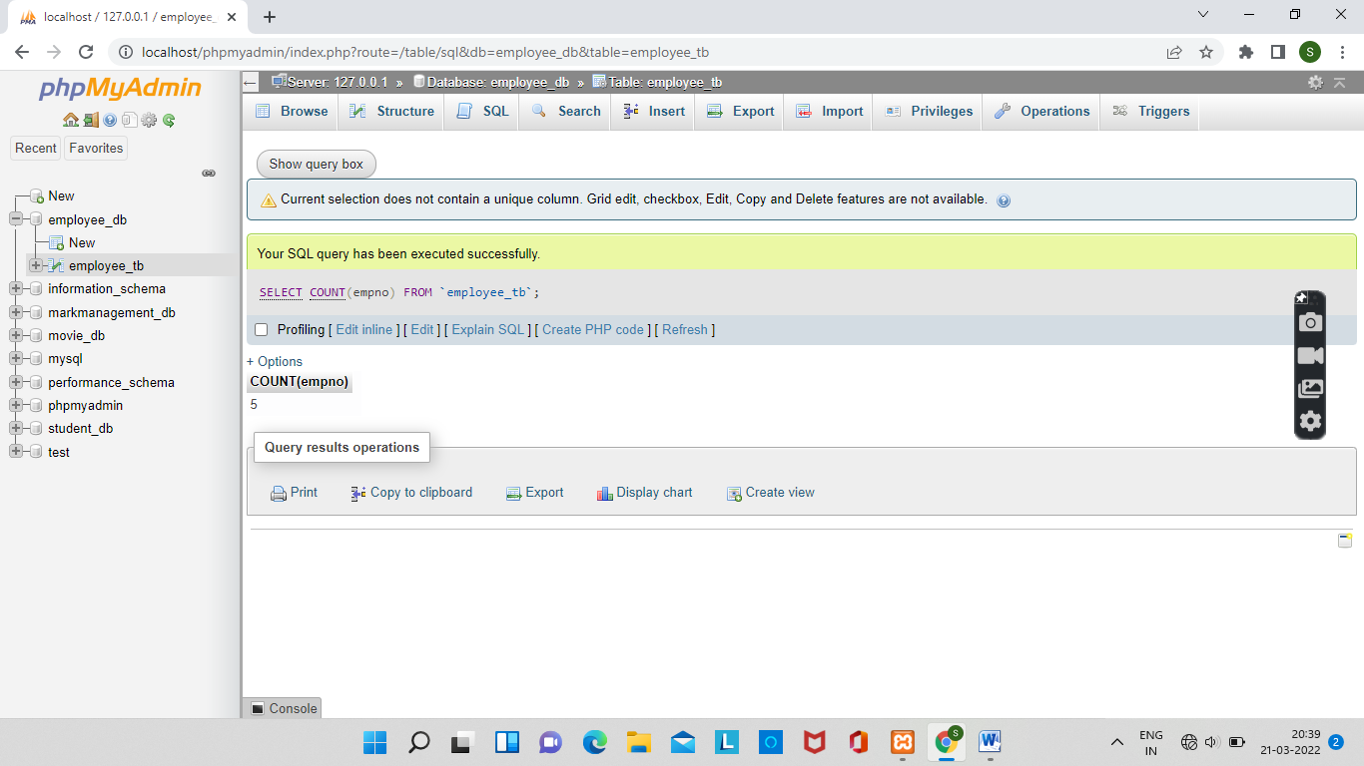

5]RETRIEVE DISTINCT NUMBER OF EMPLOYEE.

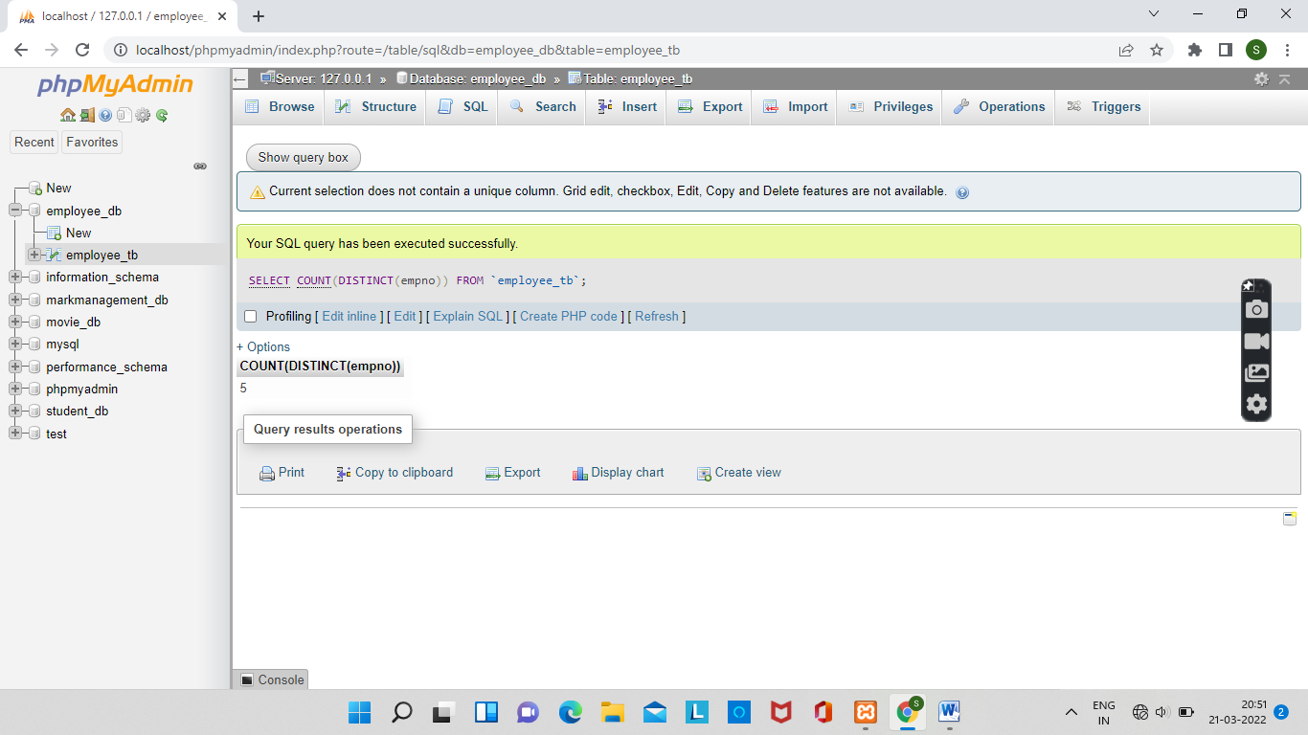

6]RETRIEVE TOTAL SALARY OF EMPLOYEE GROUP BY EMPLOYEE NAME COUNT SIMILAR NAMES.

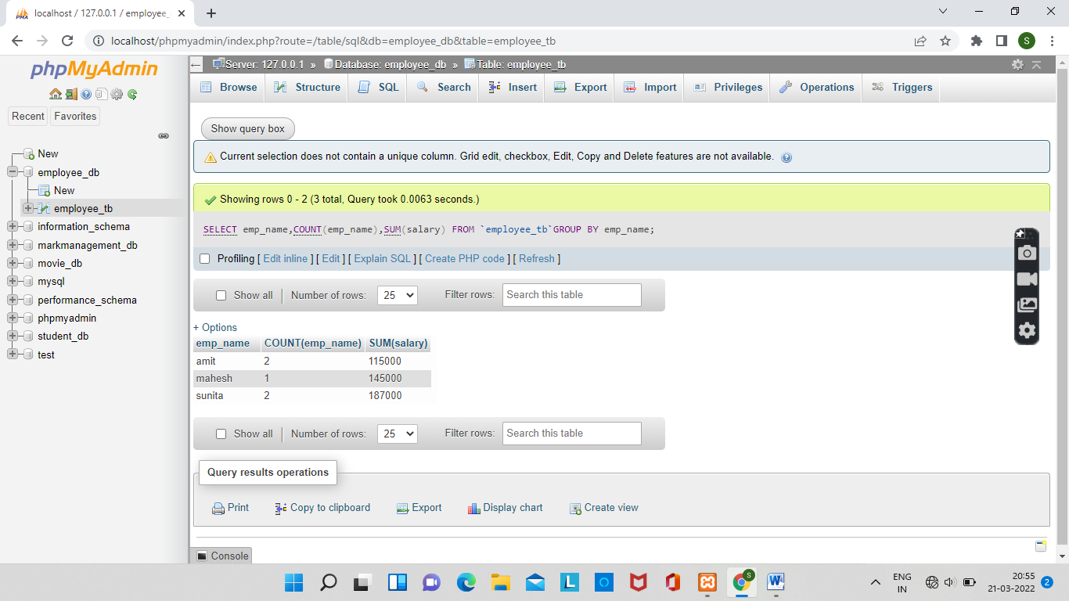

7]RETRIEVE TOTAL SALARY OF EMPLOYEE WHICH IS >120000

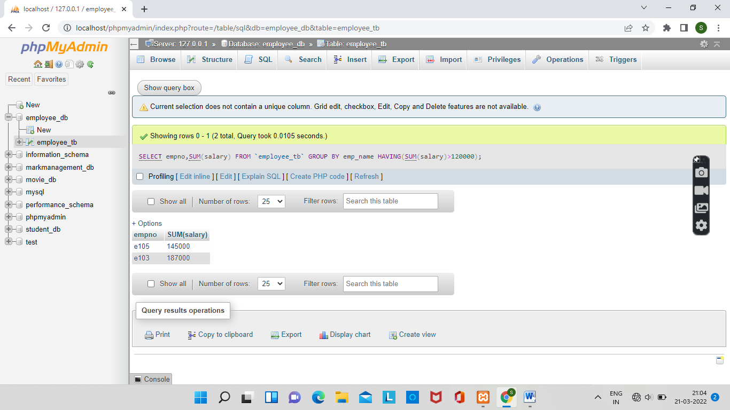

8]DISPLAY NAME OF EMPLOYEE IN DESCENDING ORDER.

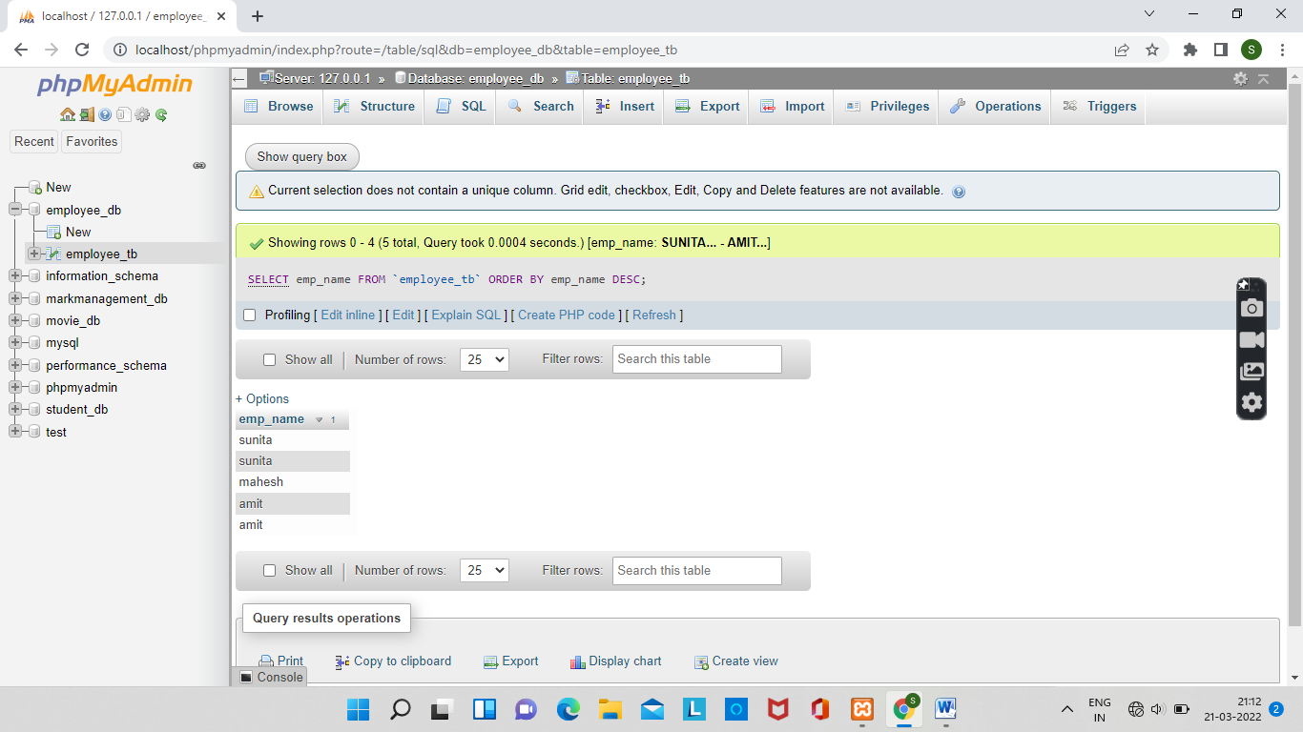

9]DISPLAY DETAILS OF EMPLOYEE WHOSE NAME IS AMIT AND SALARY GREATER THAN 50000.

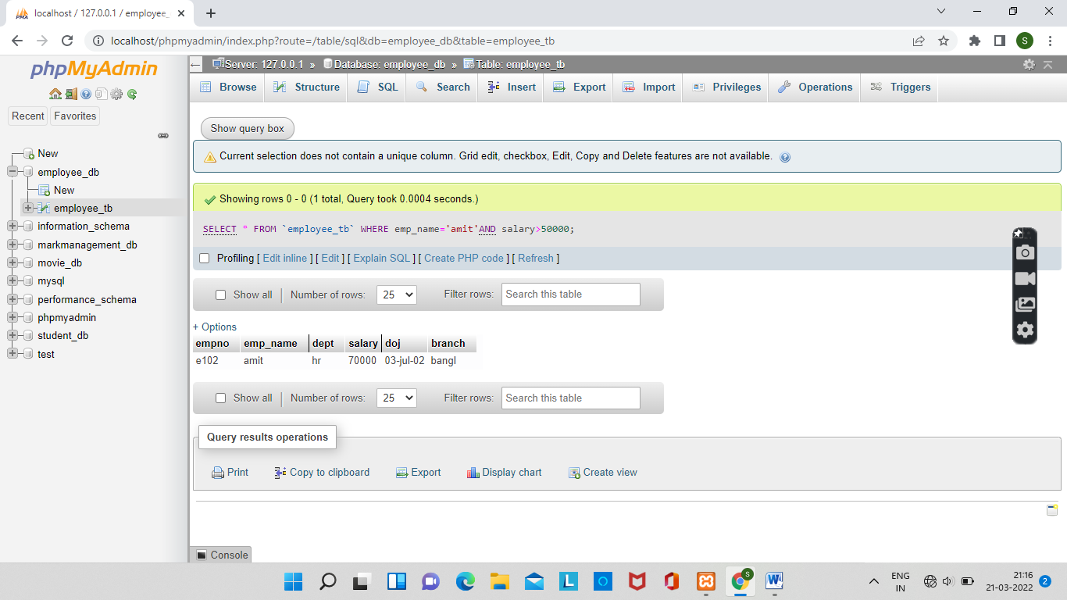

EXPERIMENT 3

1]CREATE SALES DATABASE AND THE FOLLOWING TABLES.

Cutomer_tb

Purchase_tb

Item_tb

Store_tb

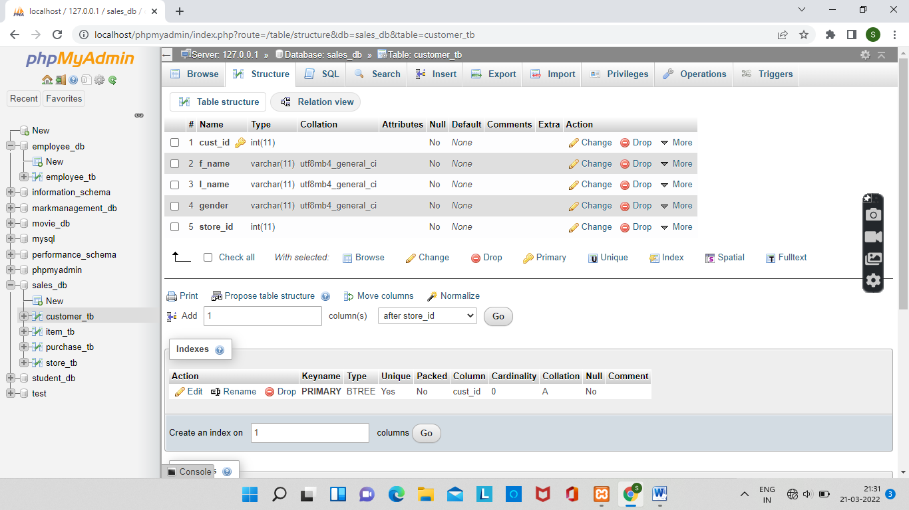

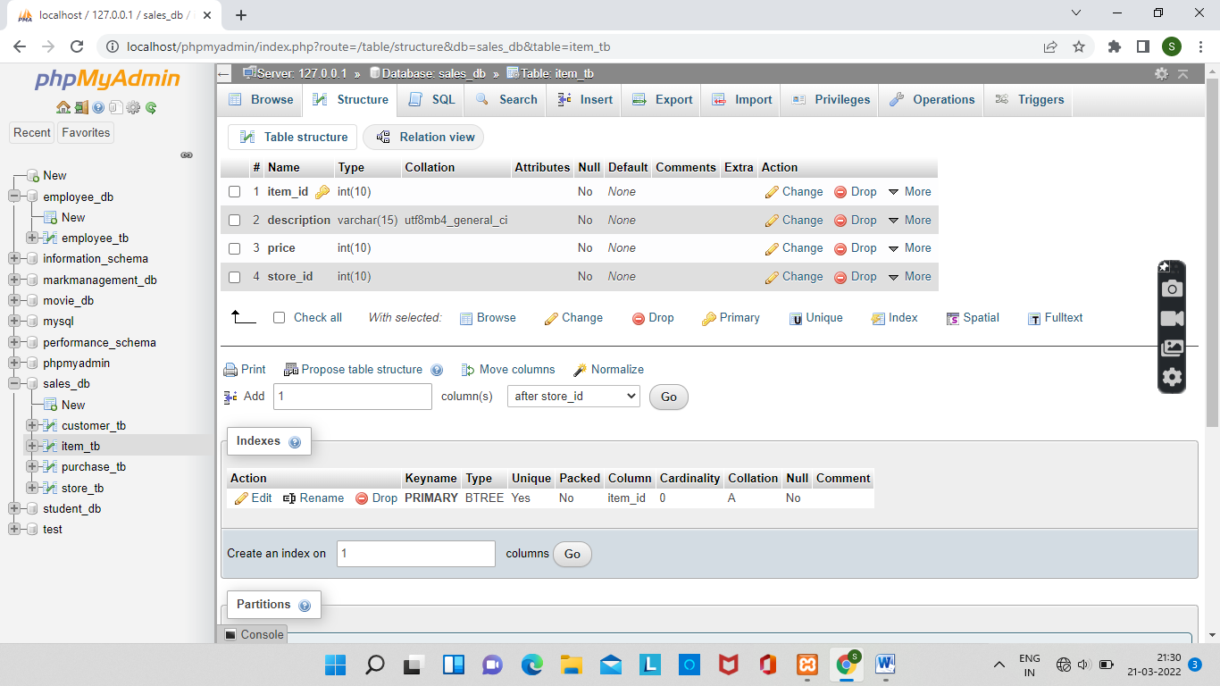

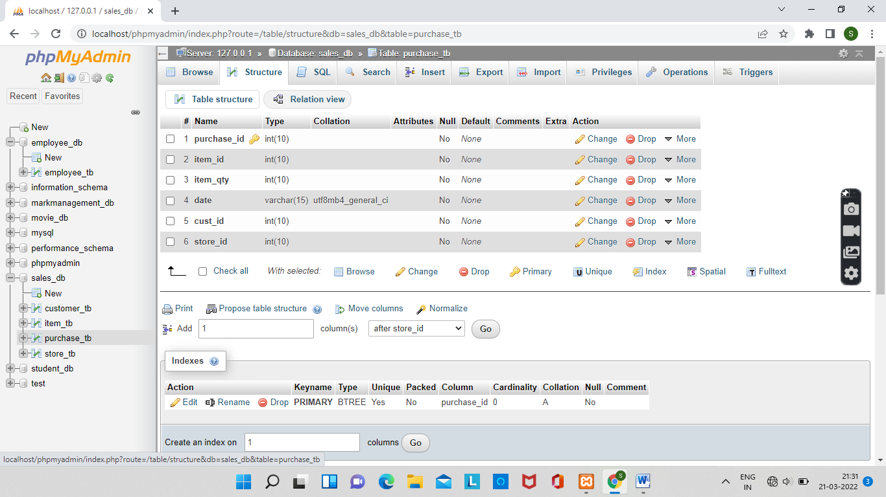

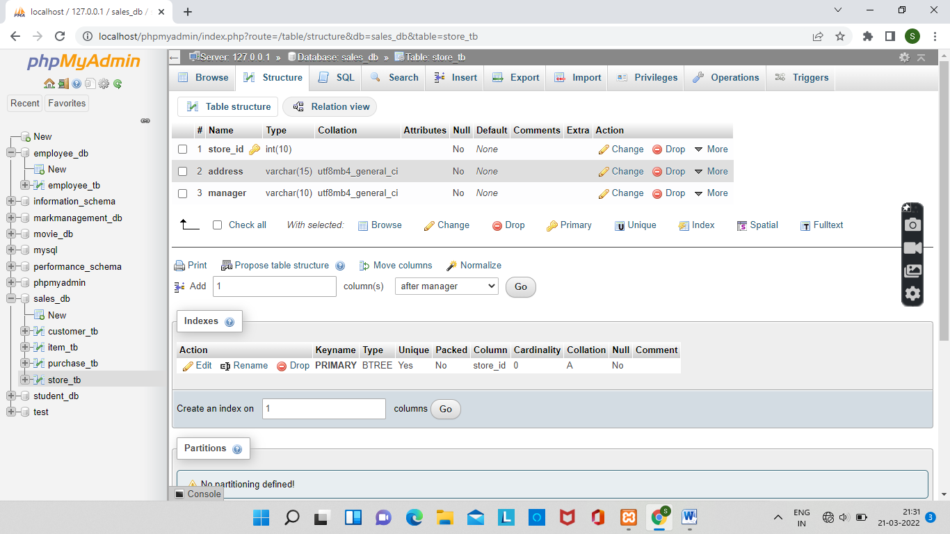

2]insert data and finally the purchase table will be.

INSERT INTO `purchase_tb`(`purchase_id`, `item_id`, `item_qty`, `date`, `cust_id`, `store_id`) VALUES ('3','6','3','2020-05-10','4','2');

INSERT INTO `purchase_tb`(`purchase_id`, `item_id`, `item_qty`, `date`, `cust_id`, `store_id`) VALUES ('4','8','1','2020-05-10','7','3');

INSERT INTO `purchase_tb`(`purchase_id`, `item_id`, `item_qty`, `date`, `cust_id`, `store_id`) VALUES ('5','5','4','2020-05-10','3','2');

INSERT INTO `purchase_tb`(`purchase_id`, `item_id`, `item_qty`, `date`, `cust_id`, `store_id`) VALUES ('6','4','2','2020-05-11','2','1');

INSERT INTO `purchase_tb`(`purchase_id`, `item_id`, `item_qty`, `date`, `cust_id`, `store_id`) VALUES ('7','6','2','2020-05-10','3','2');

INSERT INTO `purchase_tb`(`purchase_id`, `item_id`, `item_qty`, `date`, `cust_id`, `store_id`) VALUES ('8','10','2','2020-05-10','1','1');

INSERT INTO `purchase_tb`(`purchase_id`, `item_id`, `item_qty`, `date`, `cust_id`, `store_id`) VALUES ('9','6','1','2020-05-10','5','1');

INSERT INTO `purchase_tb`(`purchase_id`, `item_id`, `item_qty`, `date`, `cust_id`, `store_id`) VALUES ('10','7','1','2020-05-11','4','1');

INSERT INTO `item_tb`(`item_id`, `description`, `price`, `store_id`) VALUES ('3','wfgs','7778','1');

INSERT INTO `item_tb`(`item_id`, `description`, `price`, `store_id`) VALUES ('4','dogs','5578','1');

INSERT INTO `item_tb`(`item_id`, `description`, `price`, `store_id`) VALUES ('6','dfjs','1678','2');

INSERT INTO `item_tb`(`item_id`, `description`, `price`, `store_id`) VALUES ('8','dfks','5618','3');

INSERT INTO `item_tb`(`item_id`, `description`, `price`, `store_id`) VALUES ('5','dfys','3678','2');

INSERT INTO `item_tb`(`item_id`, `description`, `price`, `store_id`) VALUES ('4','dfrs','5674','1');

INSERT INTO `item_tb`(`item_id`, `description`, `price`, `store_id`) VALUES ('6','degs','5178','2');

INSERT INTO `item_tb`(`item_id`, `description`, `price`, `store_id`) VALUES ('10','ifgs','5628','1');

INSERT INTO `item_tb`(`item_id`, `description`, `price`, `store_id`) VALUES ('6','dpgs','5478','1');

INSERT INTO `item_tb`(`item_id`, `description`, `price`, `store_id`) VALUES ('7','dwgs','5978','1');

INSERT INTO `customer_tb`(`cust_id`, `f_name`, `l_name`, `gender`, `store_id`) VALUES ('2','salu','kb','female','1');

INSERT INTO `customer_tb`(`cust_id`, `f_name`, `l_name`, `gender`, `store_id`) VALUES ('1','sanu','k','male','1');

INSERT INTO `customer_tb`(`cust_id`, `f_name`, `l_name`, `gender`, `store_id`) VALUES ('4','sanju','b','male','2');

INSERT INTO `customer_tb`(`cust_id`, `f_name`, `l_name`, `gender`, `store_id`) VALUES ('7','sahil','m','male','3');

INSERT INTO `customer_tb`(`cust_id`, `f_name`, `l_name`, `gender`, `store_id`) VALUES ('3','sanoop','t','male','2');

INSERT INTO `customer_tb`(`cust_id`, `f_name`, `l_name`, `gender`, `store_id`) VALUES ('2','sruthy','c','female','1');

INSERT INTO `customer_tb`(`cust_id`, `f_name`, `l_name`, `gender`, `store_id`) VALUES ('3','jomol','r','female','2');

INSERT INTO `customer_tb`(`cust_id`, `f_name`, `l_name`, `gender`, `store_id`) VALUES ('1','san','p','female','1');

INSERT INTO `customer_tb`(`cust_id`, `f_name`, `l_name`, `gender`, `store_id`) VALUES ('5','anu','k','female','1');

INSERT INTO `customer_tb`(`cust_id`, `f_name`, `l_name`, `gender`, `store_id`) VALUES ('4','ankith','r','male','1');

INSERT INTO `store_tb`(`store_id`, `address`, `manager`) VALUES ('1','abcd','salu');

INSERT INTO `store_tb`(`store_id`, `address`, `manager`) VALUES ('1','aecd','sanop');

INSERT INTO `store_tb`(`store_id`, `address`, `manager`) VALUES ('2','afcd','san');

INSERT INTO `store_tb`(`store_id`, `address`, `manager`) VALUES ('3','abgd','radha');

INSERT INTO `store_tb`(`store_id`, `address`, `manager`) VALUES ('2','aycd','sangeeth');

INSERT INTO `store_tb`(`store_id`, `address`, `manager`) VALUES ('1','amcd','rahul');

INSERT INTO `store_tb`(`store_id`, `address`, `manager`) VALUES ('2','hbcd','geetha');

INSERT INTO `store_tb`(`store_id`, `address`, `manager`) VALUES ('1','abod','genu');

INSERT INTO `store_tb`(`store_id`, `address`, `manager`) VALUES ('1','aecd','srythu');

INSERT INTO `store_tb`(`store_id`, `address`, `manager`) VALUES ('1','abud','jomo');